**Download Git:**

[**https://git-scm.com/downloads**](https://git-scm.com/downloads)

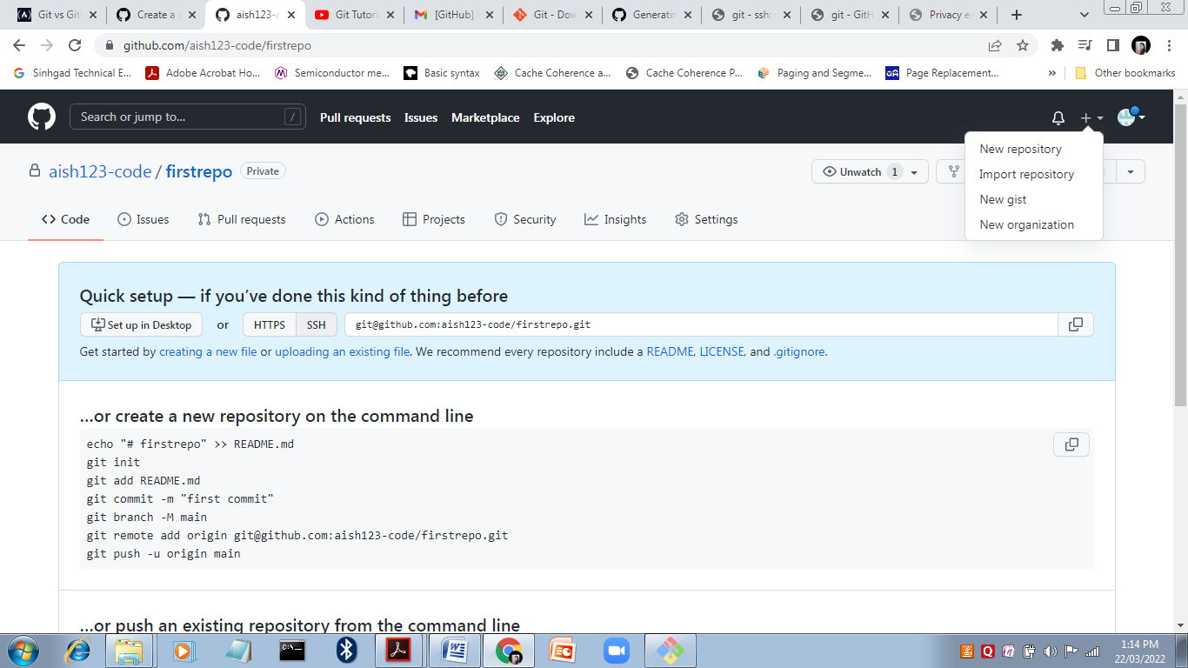

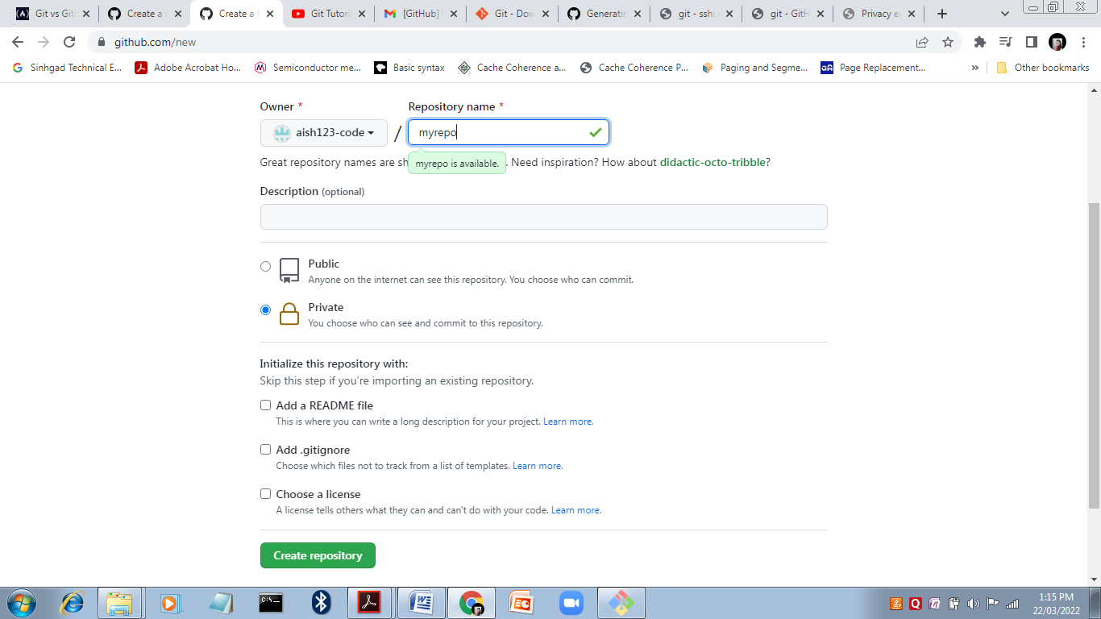

Git config

The git config command is **a convenience function that is used to set Git configuration values on a global or local project level**.

To set your Git username, run the git config –global user.name command.

Akshay@Akshay-PC MINGW64 /e/Git

$ git config --global user.name Aish

Akshay@Akshay-PC MINGW64 /e/Git

$ git config --global user.email [aishdeore2393@gmail.com](mailto:aishdeore2393@gmail.com)

Git init

git init is **one way to start a new project with Git**. To start a repository, use either git init or git clone - not both. To initialize a repository, Git creates a hidden directory called. git. That directory stores all of the objects and refs that Git uses and creates as a part of your project's history.

Akshay@Akshay-PC MINGW64 /e/Git

$ git init

Git add

The git add command **adds a change in the working directory to the staging area**. It tells Git that you want to include updates to a particular file in the next commit.

Akshay@Akshay-PC MINGW64 /e/Git (master)

$ git add .

Git initial commit

The first commit that a developer makes when they start a new software project is called the initial commit. When a developer makes a commit, they have the option of specifying message describing the changes in that commit.

Akshay@Akshay-PC MINGW64 /e/Git (master)

$ git commit -m "Initial Commit"

[master (root-commit) 1234a56] Initial Commit

2 files changed, 27 insertions(+)

create mode 100644 .gitignore

create mode 100644 index.html

Git Status

The git status command **displays the state of the working directory and the staging area**. It lets you see which changes have been staged, which haven't, and which files aren't being tracked by Git.

Akshay@Akshay-PC MINGW64 /e/Git (master)

$ git status

On branch master

nothing to commit, working tree clean

Git remote add origin

When you run **git remote add origin** git@github.com:User/UserRepo.git , then a new remote created named origin .

Akshay@Akshay-PC MINGW64 /e/Git (master)

$ git remote add origin git@github.com:aish123-code/firstrepo.git

Git push

The git push command is **used to upload local repository content to a remote repository**. Pushing is how you transfer commits from your local repository to a remote repo.

Akshay@Akshay-PC MINGW64 /e/Git (master)

$ git push origin master

ssh: connect to host github.com port 22: Connection timed out

fatal: Could not read from remote repository.

Please make sure you have the correct access rights

and the repository exists.

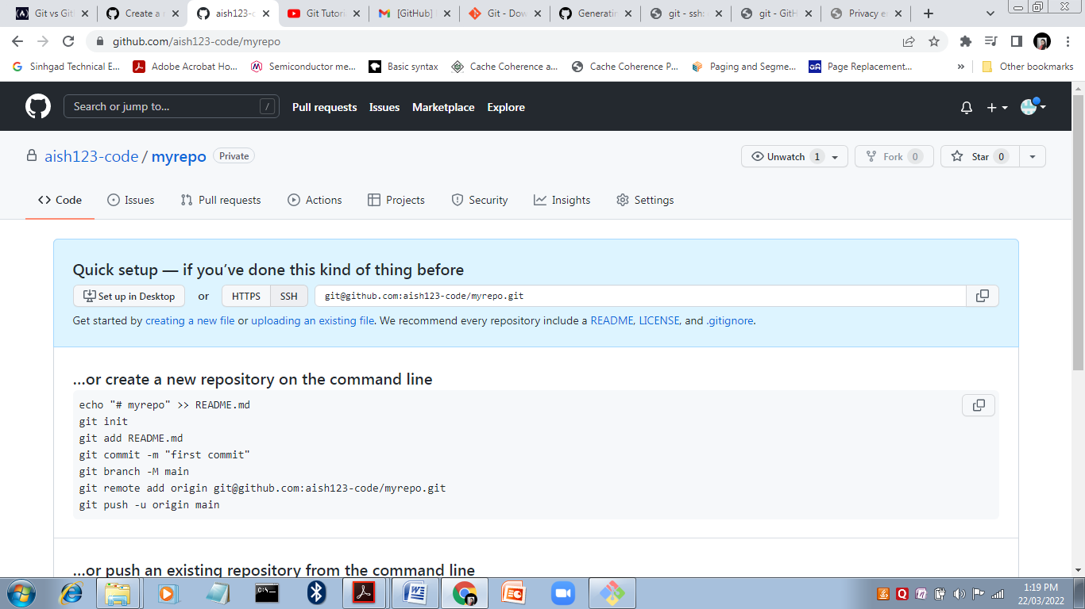

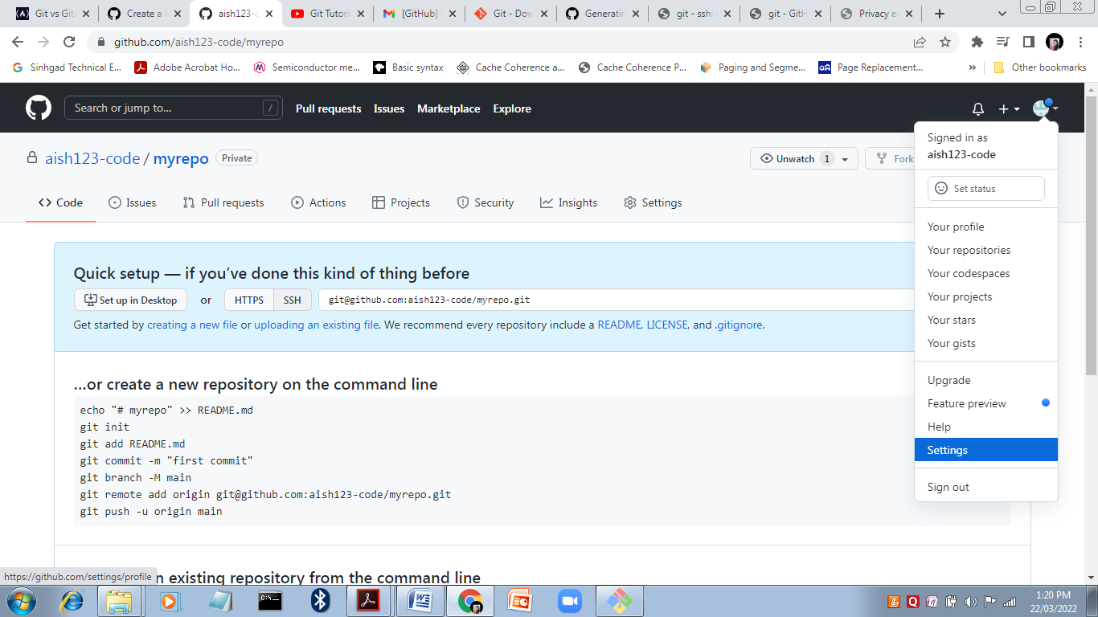

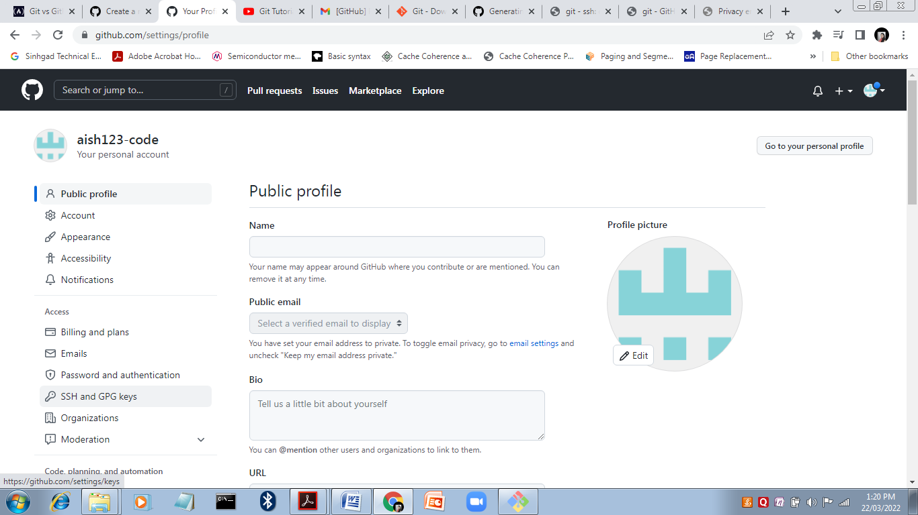

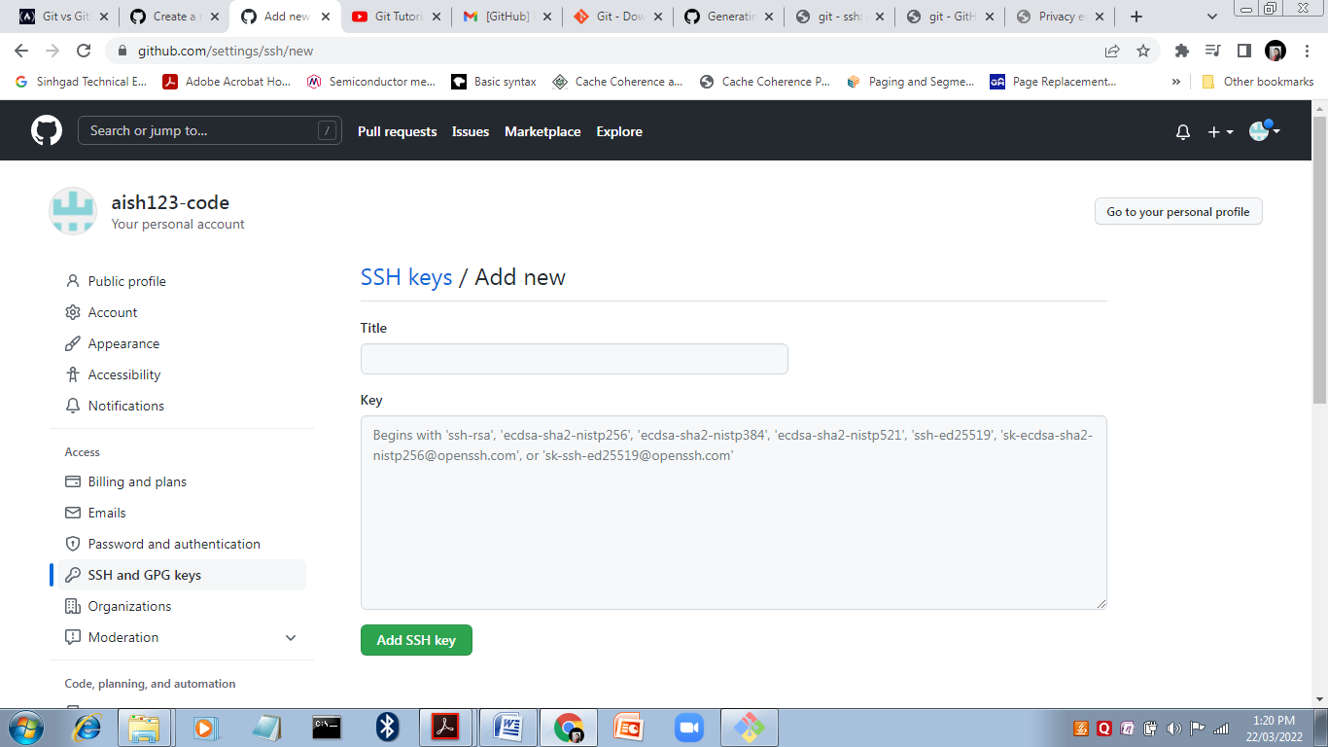

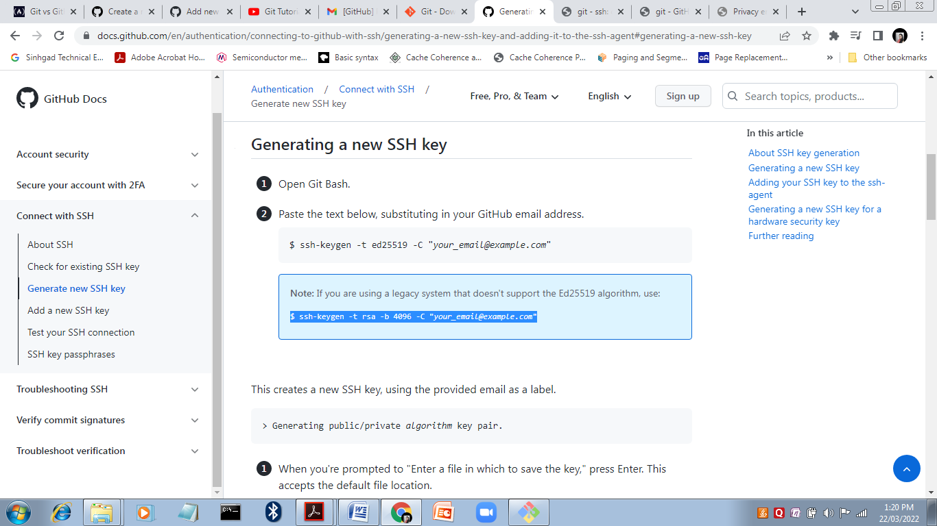

ssh-keygen -t ed25519 -C [aishdeore2393@gmail.com](mailto:aishdeore2393@gmail.com)

cat /c/Users/Akshay/.ssh/id_ed25519.pub

git push origin master

remote: Support for password authentication was removed on August 13, 2021. Please use a personal access token instead.

remote: Please see https://github.blog/2020-12-15-token-authentication-requirements-for-git-operations/ for more information.

fatal: Authentication failed for 'https://github.com/aish123-code/firstrepo.git/

Use My Account → Settings → Developer settings → Personal access tokens → Generate new token.

git remote set-url origin https://<token>@github.com/<username>/<repo>